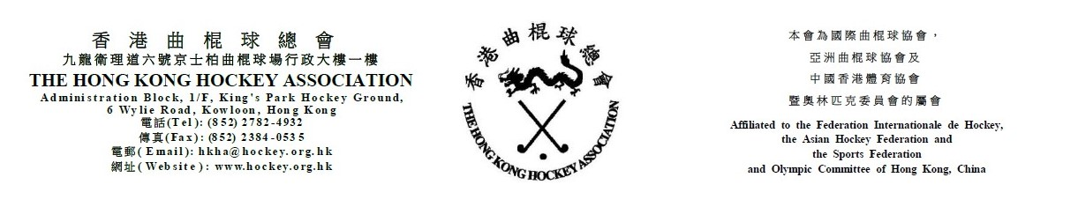

Attendance Form for
The Hong Kong Hockey Association
7th Annual General Meeting
on Friday, 31 July 2020

(Please see notes below before completing the form)
The following is authorized to represent __________________________________ (Member Club) and to vote at the HKHA AGM on Friday, 31 July 2020.

_____________________________________
(Name)
Note: Owing to the COVID-19 pandemic, only one representative from each club is invited to attend the HKHA AGM.

(Name of Club Official) |  | (Signature of Club Official)

(Position of Club Official) |  | (Date)

Notes: (1) Club officials include President, Chairman, Hon. Secretary, Convenor and Hockey Section Captain.
- This form must be received by the HKHA office no later than 5:00 pm on 24 July 2020.

